BEEDO-TRADE
for Windows
User Guide

Analyse Egyptian Exchange stocks with the Beedo technical-analysis course method: one signal, clear actions, and the evidence behind them.

Version 1.2.0 • November 2026

Contents
1. Welcome 3
What you need 3
2. Installing Beedo-Trade 4
3. Your first analysis 5
4. Reading the result 6
4.1 The signal and what to do 6
4.2 Key figures 7
4.3 The chart 8
4.4 Checklist, triggers and trade plan 9
5. Watchlist 10
6. Company fundamentals and the Screener 11
6.1 The company rating card 11
6.2 The combined view 12
6.3 The Screener 12
7. Stocks without price history (Import CSV) 13
8. Settings, updates and data 14
8.1 Light or dark 14
8.2 What Beedo-Trade remembers 14
8.3 Updating to a new version 14
9. Uninstalling 15
10. Troubleshooting 16

If the page numbers above are missing, right-click the table and choose Update Field.

1. Welcome
Beedo-Trade is a Windows program that applies the Beedo technical-analysis course to Egyptian Exchange (EGX) stocks. You type a stock code, and it shows:
- One signal on the course ladder, from Confirm Sell to Confirm Buy
- What to do if you hold cash, and if you already own the stock
- An interactive chart with the moving averages, support and resistance lines, swing points, volume and RSI
- The 11-step checklist, with the evidence for every step
- A trade plan sized to your cash and risk
- A watchlist that scans all your stocks at once

What you need
Requirement | Details
Windows 10 or 11 (64-bit) | Any recent Windows PC.
Internet connection | To download daily prices. Each analysis takes a few seconds.
Microsoft Edge WebView2 | Built into Windows 11 and most Windows 10 PCs. Setup tells you if it is missing.

IMPORTANT Not investment advice
Beedo-Trade is a learning and decision-support tool. It never places orders, and free price data can be delayed. Always check the live price and the day’s EGX disclosures before trading.

2. Installing Beedo-Trade
1 | Download the installer  Download Beedo-Trade-Setup-1.2.0.exe from the Releases page of github.com/BeedoElOmda/Beedo-Trade, or use the copy you were given.

2 | Open it  Double-click the file. If Windows shows "Windows protected your PC", click More info, then Run anyway. This appears because the app isn’t code-signed; it is normal for small independent programs.

3 | Choose who to install for  Pick Install for me only (recommended). It needs no administrator password and installs into your user folder. Choose Install for all users only if several people use this PC: Windows will ask for administrator approval, and it installs into Program Files.

4 | Accept the notice  Read the notice (not investment advice, plus the MIT license), select I accept the agreement, then Next.

5 | Keep the suggested folder  Click Next. The suggested folder already matches your choice in step 3.

6 | Shortcuts and install  Tick Create a desktop shortcut if you want one, then click Install.

7 | Finish  Leave Start Beedo-Trade now ticked and click Finish. You can also open this guide from here.

NOTE Error "Access is denied" (Error 5) during setup
This happens when Install for me only is combined with a folder inside C:\Program Files, which only an administrator can write to. Setup now warns you before this can happen. Either keep the suggested folder, or start again and choose Install for all users.

After installing you will find Beedo-Trade, Beedo-Trade User Guide and Uninstall Beedo-Trade in the Start menu. The first launch can take 10 to 20 seconds while Windows checks the new program; later launches are faster.

3. Your first analysis
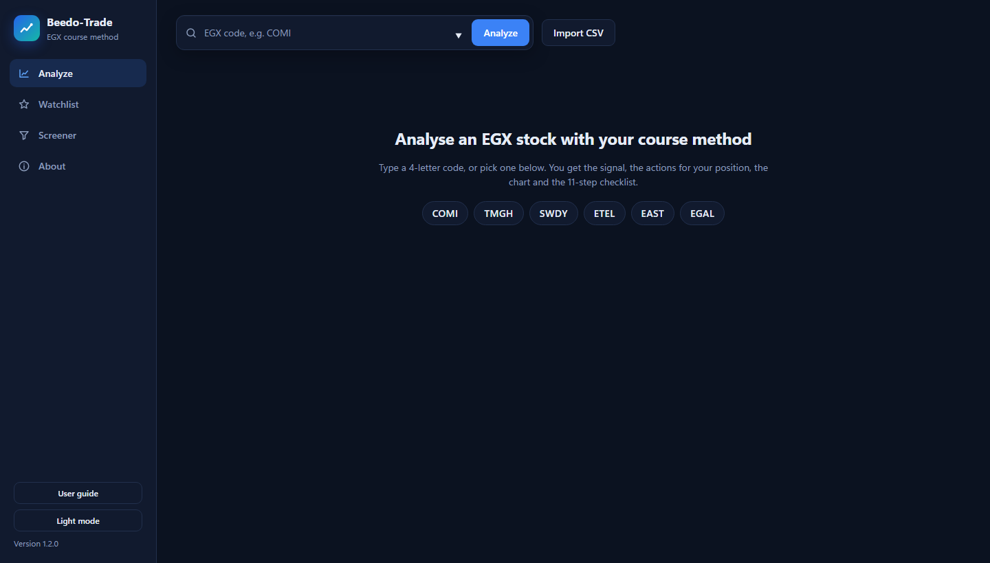
The start screen: type a code or pick one of your watchlist stocks.
- Type an EGX code in the search box, for example COMI. Suggestions appear as you type.
- Press Enter or click Analyze.
- Read the result. What to do always shows the advice for both a Cash holder (you don’t own the stock) and a Shareholder (you do).

TIP Use the 4-letter EGX code
For example COMI (CIB), TMGH (Talaat Moustafa), SWDY (Elsewedy), ETEL (Telecom Egypt), EAST (Eastern Company), EGAL (Egypt Aluminum).

4. Reading the result

4.1 The signal and what to do
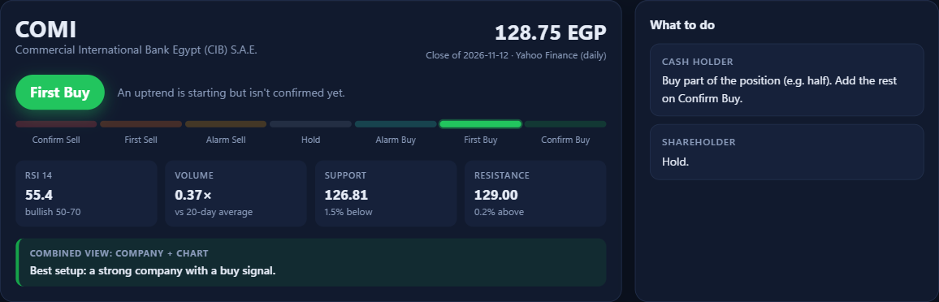
COMI: First Buy, with the actions for both positions, the key numbers and the combined view.
The coloured badge is the overall signal. The bar under it is the course’s signal ladder, with your stock’s position lit up:
Signal | Meaning | Typical action
Confirm Buy | Trend, moving averages, RSI and volume agree upward | Cash holder: buy the full position
First Buy | An uptrend is starting but isn’t confirmed | Cash holder: buy part (e.g. half)
Alarm Buy | Early signs of a turn upward | Get ready, don’t buy yet
Hold | No clear signal, or a sideways market | Stay as you are
Alarm Sell | Early signs of a turn downward | Shareholder: tighten your stop
First Sell | A downtrend is starting | Shareholder: reduce
Confirm Sell | Everything agrees downward | Shareholder: sell

The sentence next to the badge says why. When a signal is held back by a course rule (for example "price is still below MA18" or "the market is moving sideways"), it says so. The four boxes show RSI, today’s volume against its 20-day average, and the nearest support and resistance. The Combined view at the bottom joins this signal with the company’s fundamentals rating (section 6).
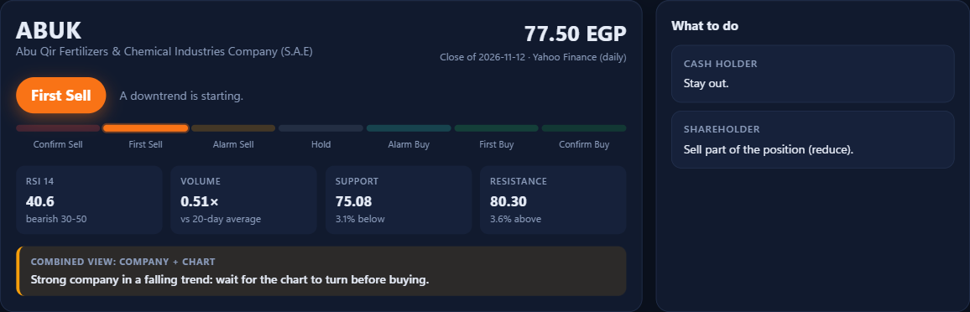
A sell example (ABUK, First Sell): each position gets its own advice.

4.2 Key figures
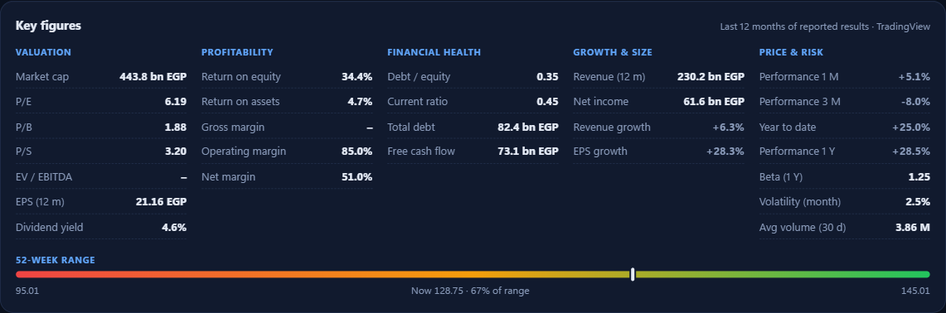
Key figures for COMI: the main financial ratios in five groups, plus the 52-week price range.
The Key figures panel shows the company’s main financial ratios from its last 12 months of reported results:
Group | What it shows
Valuation | Market cap, P/E, P/B, price/sales, EV/EBITDA, earnings per share (EPS) and dividend yield
Profitability | Return on equity and on assets, and gross, operating and net margins
Financial health | Debt to equity, current ratio (short-term bills covered if above 1), total debt and free cash flow
Growth & size | Revenue and net income over 12 months, and their yearly growth
Price & risk | Performance over 1 month, 3 months, year to date and 1 year, beta, monthly volatility and average volume

The bar underneath shows where today’s price sits between the 52-week low (left) and high (right). Hover over a figure for a short explanation. A dash (–) means the company hasn’t reported that figure.

4.3 The chart
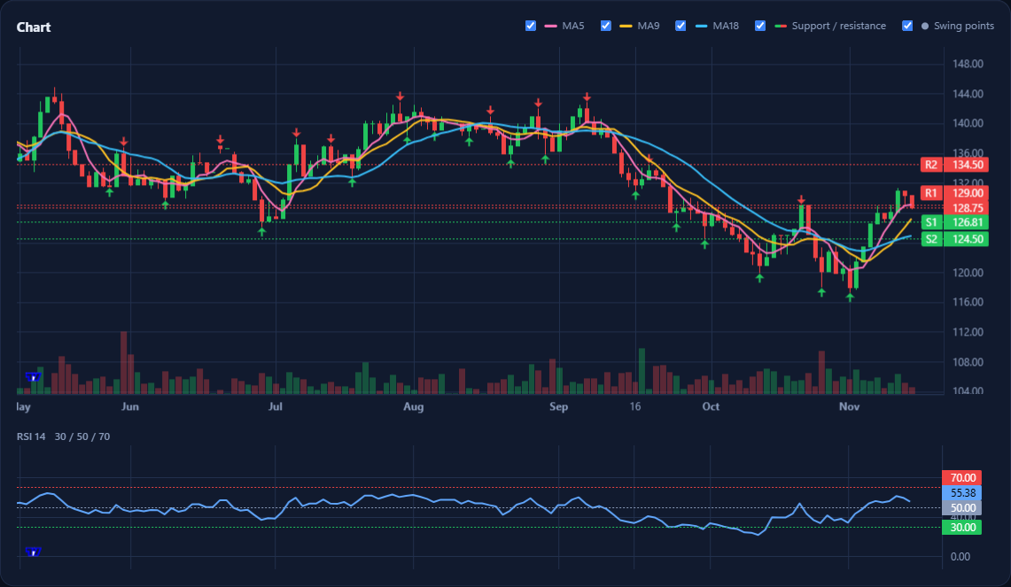
Candles with MA 5 / 9 / 18, support (S) and resistance (R) lines, swing arrows, volume and RSI.
- Moving averages: MA5 (pink), MA9 (yellow), MA18 (blue). The course’s crossovers are 5×9 = Alarm, 5×18 = First, 9×18 = Confirm.
- S1 / S2 and R1 / R2: the nearest recent support (green) and resistance (red) levels.
- Arrows: swing highs (red, pointing down) and swing lows (green, pointing up). Use them to judge patterns such as head and shoulders, double tops or triangles (checklist steps 10 and 11).
- RSI panel: with the 30, 50 and 70 lines.
- Controls: scroll the mouse wheel over the chart to zoom, drag to move back in time, and use the tick boxes above the chart to show or hide each layer.

4.4 Checklist, triggers and trade plan
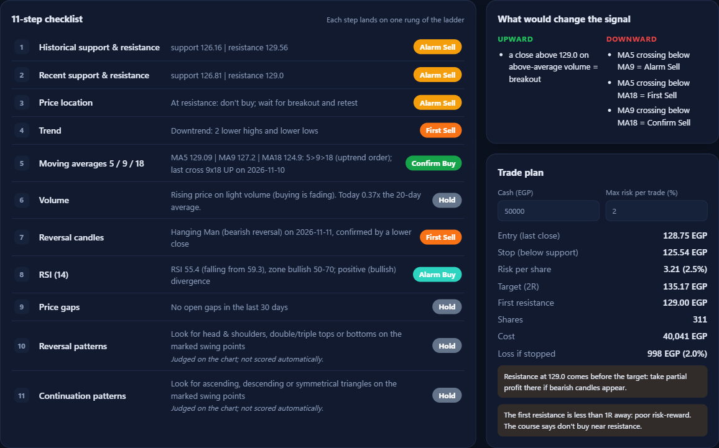
The 11-step checklist (left), what would change the signal, and the trade plan (right).
11-step checklist: each course step with its reading and its rung on the ladder. Steps 10 and 11 (chart patterns) are judged by you on the chart.
What would change the signal: the next events up and down, such as "MA9 crossing above MA18 = Confirm Buy" or "a close below 126.81 = support broken".
Trade plan: enter your cash and the most you are willing to lose per trade (default 2%). It shows the entry (last close), a stop just below support, a 2R target, the number of shares, the cost and the loss if the stop is hit. Yellow notes warn when resistance is in the way. On weaker signals the plan is labelled as one to have ready, not a trade for today.

5. Watchlist
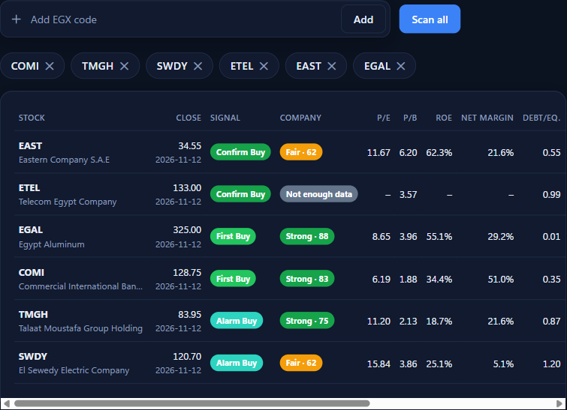
The watchlist after "Scan all", strongest buy first.
- Open Watchlist in the left menu.
- Type a code in Add EGX code and click Add. Remove a stock with the ✕ on its chip.
- Click Scan all. Every stock is analysed and sorted from the strongest buy to the strongest sell, with each company’s rating, its main ratios (P/E, P/B, ROE, net margin, debt/equity, EPS growth, dividend yield, market cap, year-to-date performance) and the combined view.
- Click a column header to sort by it (click again to reverse). Click any row to open its full analysis.
Your watchlist is saved automatically and shown as quick-pick buttons on the start screen.

6. Company fundamentals and the Screener
Your course tells you when to buy or sell. Fundamentals tell you whether the company is worth owning at all. Beedo-Trade rates every company with standard rules, then combines that rating with the course signal.

6.1 The company rating card
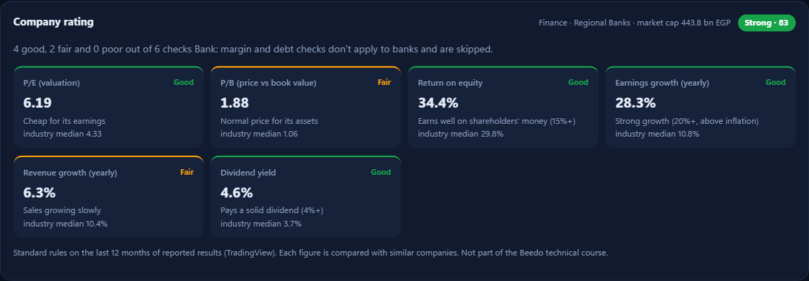
COMI: rated Strong (83). Each tile shows the figure, its rating and the median of similar companies.
Each figure is rated Good, Fair or Poor, and shown next to the median of similar companies (same industry where possible, otherwise the same sector or the whole market):
Check | Good | Poor
P/E (valuation) | 10 or less, or well below peers | Over 30, far above peers, or loss-making
P/B (price vs book) | 1.5 or less (banks: 1.0) | Over 5 (banks: 2.5) and above peers
Return on equity | 15% or more | Under 8%
Net profit margin | 10% or more | Under 3%
Debt to equity | 0.5 or less | Over 1.5
Earnings / revenue growth | 20% or more a year | Falling
Dividend yield (bonus) | 4% or more | No penalty for paying no dividend

Overall rating: Strong (70 or more out of 100), Fair (45 to 69) or Weak (under 45). Banks skip the margin and debt checks, which don’t fit how banks work. If fewer than three key figures are reported, the rating is Not enough data. This is common for smaller companies.
NOTE Why growth needs 20% to count as good
Egypt’s high inflation lifts every company’s sales and profits in pounds. Growth below inflation means the business is shrinking in real terms, so 20% a year is the bar for "Good".

6.2 The combined view
Company | Course signal | Combined view
Strong | First / Confirm Buy | Best setup: a strong company with a buy signal
Strong | Alarm Buy or Hold | Put it on your watchlist and wait for a buy signal
Strong | Any sell | Wait for the chart to turn before buying
Fair | First / Confirm Buy | Acceptable: consider a smaller position
Weak | First / Confirm Buy | Speculative: small size, or skip it
Weak | No buy signal | Avoid

6.3 The Screener
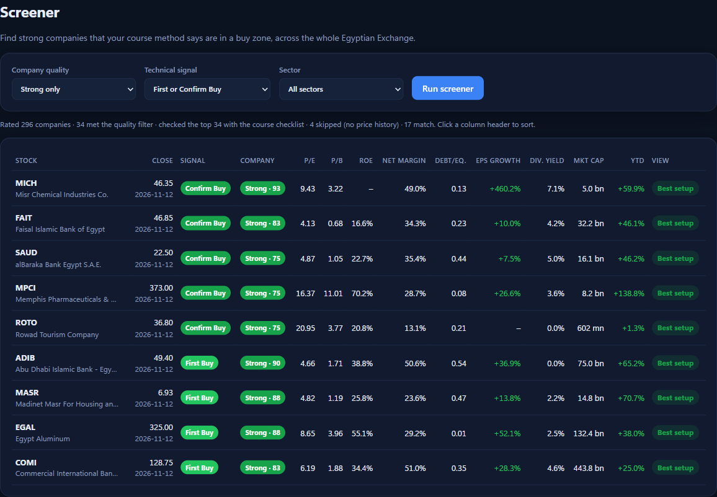
The Screener: strong companies that are in a buy zone right now.
- Open Screener in the left menu.
- Choose the Company quality (Strong only, or Strong or Fair), the Technical signal you want, and optionally a Sector.
- Click Run screener. It rates every EGX company, then runs your course checklist on the best 40. This takes 10 to 40 seconds.
- The results show the same ratio columns as the Watchlist. Click a column header to sort, for example by P/E or dividend yield. Hover over a row to read its full combined view, and click it to open the full analysis.

TIP Use the Screener to find ideas, then check them
The Screener narrows about 300 stocks to a short list. Open each result, read its chart and checklist, and confirm the live price and the day’s news before acting.

7. Stocks without price history (Import CSV)
Prices come from Yahoo Finance, which covers the larger, widely traded EGX stocks but not every company. If a stock isn’t covered, you’ll see "Yahoo Finance has no price history". You can still analyse it from a file of daily prices:
- Export daily prices from your broker or a charting website as a CSV file, with at least 60 trading days (a year is best).
- Type the stock code in the search box (optional, used as the name), then click Import CSV and choose the file.

The file needs | Accepted forms
Date | 2026-11-05, 05/11/2026 or 11/05/2026 (one style for the whole file)
Open, High, Low | Plain numbers; thousands separators like 1,234.5 are fine
Close | A column named Close, Price or Last
Volume (optional) | Volume or Vol.; values like 1.2M or 850K are understood

8. Settings, updates and data

8.1 Light or dark
Click Light mode / Dark mode at the bottom of the left menu.
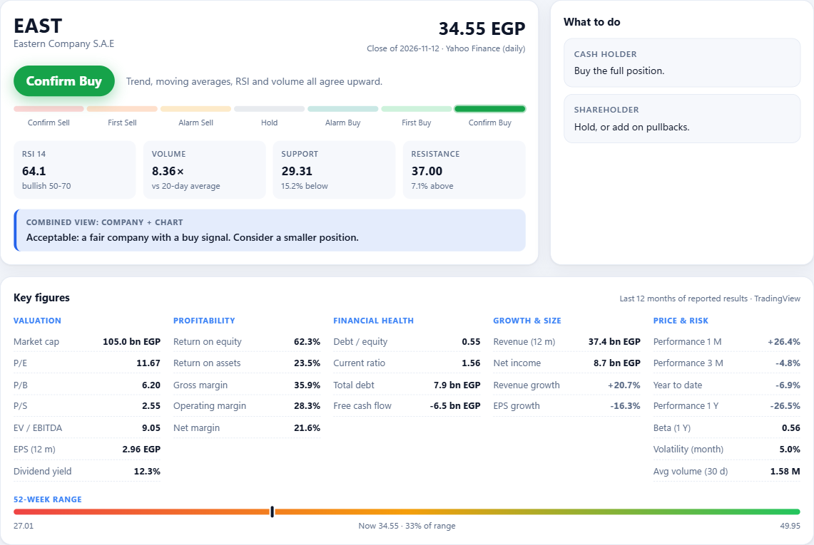
Light theme (EAST, Confirm Buy).

8.2 What Beedo-Trade remembers
Your watchlist, cash, risk %, position (cash holder or shareholder) and theme are saved automatically in your user profile, in the folder %APPDATA%\BeedoTrade. The About page shows the exact folder.

8.3 Updating to a new version
- On the About page, click Check for updates. This opens the GitHub Releases page.
- Download the newer Beedo-Trade-Setup file and run it. It replaces the old version in place and closes Beedo-Trade first if it is open.
- Your watchlist and settings are kept.

9. Uninstalling
Use either of the standard Windows ways:
A | From Windows Settings  Open Settings → Apps → Installed apps, find Beedo-Trade, click the ⋯ button and choose Uninstall.

B | From the Start menu  Open the Start menu, find Uninstall Beedo-Trade and click it.

At the end, Beedo-Trade asks whether to also delete your settings and watchlist. Choose No to keep them for a future install, or Yes to remove everything. The program, its shortcuts and this guide are always removed.

10. Troubleshooting
Problem | What to do
Setup: "Access is denied" (Error 5) | Choose "Install for me only" and keep the suggested folder, or choose "Install for all users" to install into Program Files (needs administrator approval).
"Windows protected your PC" | Click More info, then Run anyway. The app isn’t code-signed.
The app window stays blank | Install Microsoft Edge WebView2 (free from Microsoft), then start Beedo-Trade again.
"Yahoo Finance has no price history" | Yahoo doesn’t carry that stock. Use Import CSV (section 7).
"Could not reach Yahoo Finance" | Check your internet connection, firewall or VPN, then try again.
Prices look a day old | Free data can lag, and on Friday and Saturday the latest price is Thursday’s close. Check the live price in your broker app.
Company rating says "Not enough data" | TradingView has too few reported figures for that company (common for smaller firms). Use the technical signal and keep positions small.
The first start is slow | Normal: Windows checks a new program the first time. Later starts are faster.

Still stuck? On the About page, click Report a problem to open an issue on GitHub, and describe what you did and what you saw.

IMPORTANT Not investment advice
Beedo-Trade applies a technical-analysis method for learning and decision support. It does not know your full financial situation and does not place orders. You make every decision.

